***SOFTWARE TESTING ASSIGNMENT***

**Module -1 (Fundamental)**

Q1. What is SLDC.?

Ans – SDLC is a software development life cycle which is a process used by software industry to design, develop and test the software.

Q2. What is Software Testing?

Ans - Software testing is a part of software development process

Software testing is an activity to detect and identify the defects in software.

The objective of testing is to release quality product to the client.

Q3. What is Agile Methodology?

Ans – **Agile methodology** – Agile is an interactive and incremental process.

**Agile principles** –

* Customer no need to wait for long time.
* We develop, test and release price of software to customer with few numbers of features.
* We can accept/accommodate requirement changes.

Q4. What is SRS?

Ans – **SRS –** A software requirement specifications is a complete description of the behavior of the system to be developed.

SRS is a detailed document outlining the requirements for a software applications or system. It serves as a blueprint for developer. Stakeholder and tester to ensure everyone understands what the software needs to do.

Q5. What are OOPs?

Ans **– OOPS** – OOP stands for object-oriented programing language the main purpose of OOP is to deal with real world entity using programing language.

Q6. Write basic concepts of OOPs.

Ans **- Concepts of OOP**

* Object
* Class
* Encapsulation
* Inheritance
* Polymorphism
* Abstraction

Q7. What is Class?

Ans – **Class** – A class represents an abstraction of the object and abstracts the properties and behavior of that object. Class is a blueprint or templates for an object.

Q8. What is object?

Ans – **Object-** An object represents and individual, identifiable item unit or entity, either real or abstract with a well-defined role in the problem domain. This is the basic unit of object-oriented programming.

Q9. What is Encapsulation?

Ans **– Encapsulation** – Wrapping data and behavior of an object into single unit is called encapsulation.

Q10. What is Inheritance?

Ans – **Inheritance** – To access property of one class to another class is called inheritance

Q11. What is Polymorphism?

Ans – **Polymorphism** – Same function in but having different functionality with different behavior is called polymorphism.

Q12. Write SDLC Phases with basic introduction.

Ans.- **SDLC Phase -**

* **Analysis Phase -**The analysis phase defines the requirements of the system, independent of how this requirement will be accomplished.
* **Design Phase**- The design team can now expand upon the information establish in the requirement document.

1. Design Architecture document
2. Implementation Plan
3. Critical priority Analysis
4. Performance Analysis
5. Test plan

* **Implementation Phase-**

In the implementation Phase, the team builds the components either from scratch or by composition.

Given the architecture document from the design phase and the requirement document from the analysis phase, the team should build exactly what has been requested, through there is still room for innovation and flexibility.

* **Testing phase: -** The testing phase separate phase which is performed by a different team after the implementation is completed

It is validating the solution against the requirements.

* **Maintenance Phase: -** Software maintenance is also one of the phases in the system development life cycle (SDLC) as it applies to software development. The maintenance phase is the phase which comes after deployment of the software into the field.

Q 13) Explain phases of the water fall modal.

Ans. Water fall module: - The water fall module is a linear sequential software development methodology divided into distinct phase. Here are the typical phase of the waterfall modal.

* **Requirement Gathering: -**

1) Define project scope and objectives.

2) Identify stakeholders and their needs.

3) Create a software requirements specification (SRS).

* **Analysis: -**

1) Review and validate requirements.

2) Identify potential risk and dependencies.

3) Develop a de tailed analysis document.

4) Define project timeline and budget.

* **Design: -**

1) Create architectural and detailed design.

2) Develop user interface (UI) and user experience designs.

3) Produce a detailed design document.

* **Implementation: -**

1) Write code based on design specifications.

2) Develop software components and modules.

3) Conduct unit testing and integration testing.

4)Implement debugging and error handling.

* **Testing: -**

1)Plan and create test cases.

2) Conduct functional, performance, and security testing.

3) Identify and report defects.

* **Maintenance: -**

1) Monitor software performance

2) Fix defect and implement changes.

3) Provide ongoing support and updates.

Q 14) Write Agile manifesto principles.

Ans. **Agile Manifesto Principles: -**

* **Individuals and interactions**- In agile development, self-organization and motivation are important, as are interactions like co-location and pair programming.
* **Working Software: -** Demo working software is considered the best means of communication. With the customer to understand their requirement, instead of just depending on documentation.
* **Customer collaboration: -** As the requirements cannot be gathered completely in the beginning of the project due to various factors, continuous customer interaction is very important to get proper product requirements.
* **Responding to change: -** Agile development is focused on quick response to change and continuous development.

Q 15) Explain working methodology of agile model and also write pros and cons.

Ans. The agile model is an interactive and incremental software development methodology focusing on flexibility, customer satisfaction and rapid deli very.

**Agile Working Methodology: -**

1. **Project Planning: -** Identify goals, requirements and stakeholders.
2. Iteration / sprint Planning: - Break down work into smaller tasks (2-4 weeks).
3. **Daily stand-ups: -** Team discusses progress. Plans and obstacles.
4. **Development: -** Implement tasks from iteration backlog.
5. **Testing and Integration: -** Continuous testing and integration.
6. **Review and retrospective** – Evaluate progress, identify improvements.
7. **Deployment –** Release working software to customers.

**Pros: -**

Flexibility: Adapts to changing requirements

Faster time to market: Rapid delivery and deployment.

Customer satisfaction: Active involvement and feedback.

Quality Focus: Continuous testing and improvement.

Risk Reduction: Early identification and mitigation.

**Cons: -**

Complexity: Difficult to scale in large project.

Lack of Documentation: Limited documentation.

Dependence on team: Success relies on team cohesion.

Time consuming: Frequent meetings and planning.

Scope creep: Difficulty in defining project scop.

Higher Cost: Increased overhead due to iterative approach.

Q 16) Write phases of spiral model.

**Spiral model phases –**

* **Planning –** Define project scope, goals and deliverables identify stakeholder and their requirements establish project timeline and budget.
* **Risk Analysis** – Identify potential risks and threats assess risk impact and likelihood.
* **Engineering (Design, implementation and Testing) –** Design and develop software, conduct unit testing and integration testing, Ensure Quality and reliability.
* **Evaluation (Customer review and feedback) –** Evaluate software against requirement. Gather customer feedback. Identify areas for improvement. Identify areas for improvement.

Q17) Draw use case on online shopping product using payment gateway.

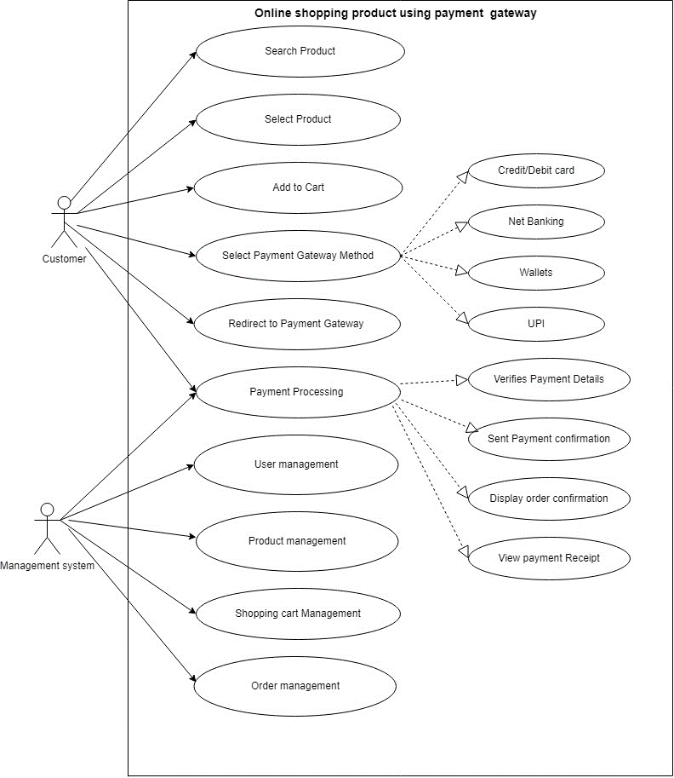

Q18) Draw use case on online book shopping.

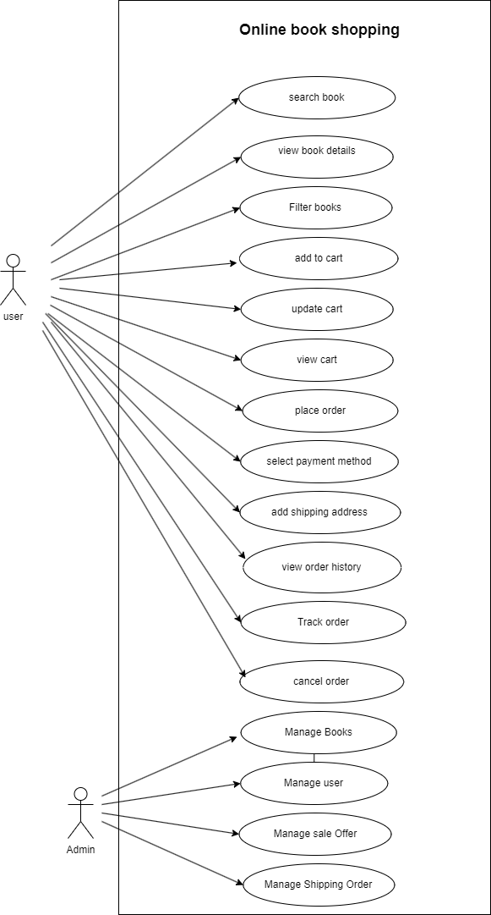

Q18) Draw use case on online bill payment system.

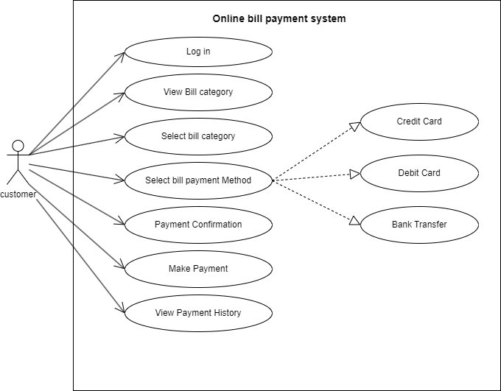

Q20) Draw use case on online shopping product using COD.

